
ECONOMIC COMMUNITY OF
WEST AFRICAN STATES
COMMUNAUTÉ ECONOMIQUE DES
ETATS DE L'AFRIQUE DE L'OUEST
Department Education, Sciences and Culture

INTERSHIP IMMERSION OF YOUNG GRATUATES
IN THE PROGRAMS OF ECOWAS

Call for applications form
- CONTEXT AND JUSTIFICATION
- The Economic Community of West African States (ECOWAS) launches the immersion internship program for young graduates in ECOWAS institutions.
- The program is open to young graduates from the fifteen ECOWAS Member States, aged 30 years or less.

- OBJECTIVES OF THE INTERNSHIP
- Overall objective:
- Contribute to the professional integration of young graduates, by offering them the opportunity to get to know ECOWAS programs better, at the same time for the Interns to offer their contribution for efficiency in overall program implementation.

- Specific objectives:
- Offer the possibility of an immersion (internship) in the services of the regional institution (Institutions, Agencies, Departments, Resident Representations);
- Create a framework that allows young graduates to contribute to the implementation of major ECOWAS programs within Departments, Agencies, Representations and Institutions.

- EXPECTED RESULTS
- Young people acquire professionalizing experience through their immersion in ECOWAS programs, essential for their career;
- Young graduates contribute to the implementation of ECOWAS programs.

- TARGET AUDIENCE:
- Young graduates from ECOWAS Member States, with 30 years old maximum.
- SELECTION CRITERIA
- Be a citizen of an ECOWAS Member States;
- Be a student or hold a Certificate, at the Bachelor (Bsc), Master, PhD or equivalent certificate;
- Submit:
- a request to the ECOWAS Commissioner in charge of Education, Science and Culture which describes the motivation of the candidate with expression of his centers of interest, as well as the candidate's commitment to respect the terms and conditions of the internship;
- a Curriculum vitae;
- a copy of the birth certificate;
- a copy of the academic certificate or its equivalent;

- MODALITIES AND SELECTION PROCESS
- Internship positions are defined with the Departments and reception structures before each Program, which allows the candidate to apply according to the need expressed by these structures;
- 60 internship positions are expressed for the year 2021 according to the attached list.
- The selection is to be done by a Technical Selection Committee of the ECOWAS Commission under the coordination of the Department of Education, Science and Culture;
- Only the selected candidates are contacted for the rest of the process.

- CONDITIONS OF THE INTERNSHIP
- • All internship conditions are defined in the Terms of Reference attached to this call.

- DURATION, PLACE AND TERMS OF THE INTERNSHIP
- The Immersion Program for young graduates in ECOWAS programs lasts one year over a period of 12 months maximum {Not renewable};
- The Program is carried out in the Departments, Agencies, Representations and Institutions of ECOWAS, or any other place duly designated by ECOWAS;
- The young graduate benefiting from the Program produces a report at the end of the internship in three copies, one copy being sent to the ESC Department, another copy to the user department and the last copy for the intern in person;
- The practical modalities of the course will be defined in connection with the reception department;
• The intern is required (mandatory) to participate in person or online (for those not residing in Abuja) in any information or internship feedback meeting convened by the Program Coordination.

- PROGRAM COORDINATION
- Coordination of the internship program is carried out by the Education, Science and Culture Department of ECOWAS.
NB: Please read the attached terms of reference and the internship position list in full. The terms of reference give more details on the internship conditions and the list of specifies the need for the position expressed, the place of the internship and the level of the certificate required.

• Publication date: August 20, 2021
• Closing date of the call: September 3, 2021

NB: An internship candidate is not allowed to apply in more than 2 positions.

Attached documents:
-Terms of reference

For any further information or to apply, please write to the following address:
escinternship2021@ecowas.int
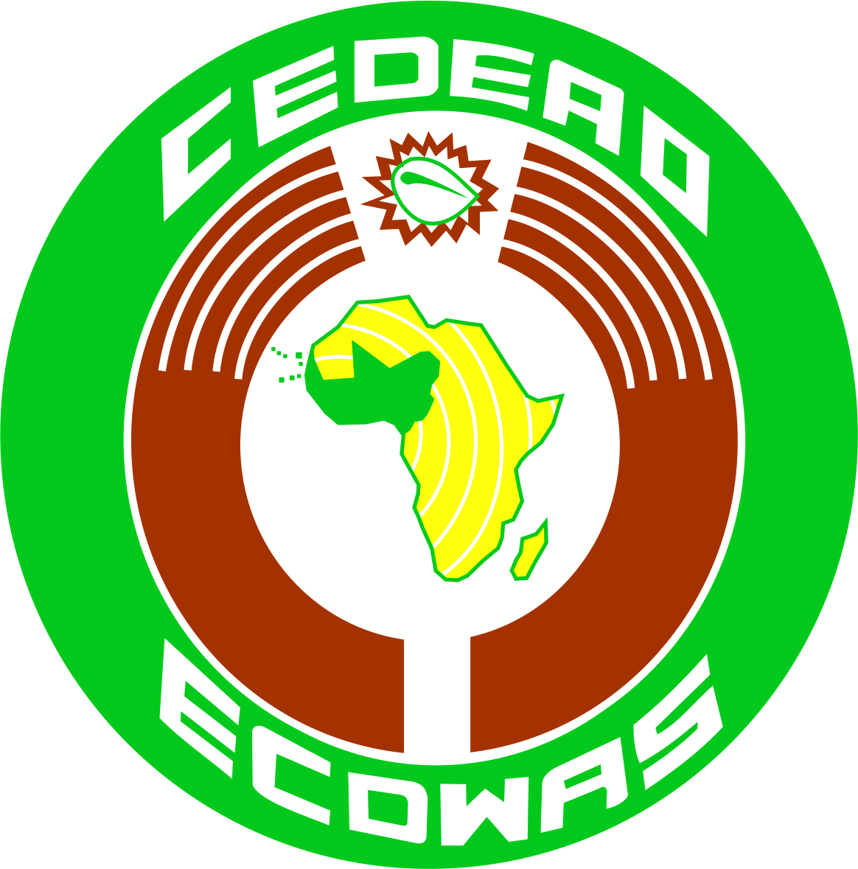
ECONOMIC COMMUNITY OF
WEST AFRICAN STATES
COMMUNAUTÉ ECONOMIQUE DES
ETATS DE L'AFRIQUE DE L'OUEST
Department Education, Sciences and Culture

STAGE D’IMMERSION DES JEUNES DIPLOMES DANS LES PROGRAMMES DE LA CEDEAO
INTERNSHIP IMMERSION OF YOUNG GRADUATES IN ECOWAS INSTITUTIONS

List of needs
N° | Institution | Structure d’accueil | Profil demandé | Nombre | Lieu du stage | Observations
West African Heath Organisation (WAHO)
 | West African Heath Organisation (WAHO) |  | Communication and institutional branding | 1 | Bobo-Dioulasso  (Burkina Faso) | Master Degrees
 | West African Heath Organisation (WAHO) |  | Monotoring and Evaluation | 1 | Bobo-Dioulasso  (Burkina Faso) | Master Degrees
 | West African Heath Organisation (WAHO) |  | Administration and finance | 2 | Bobo-Dioulasso  (Burkina Faso) | Master Degrees
 | West African Heath Organisation (WAHO) |  | Surveillance/Epidemiology/Public Health | 1 | Bobo-Dioulasso  (Burkina Faso) | Master Degrees
Auditor General
 | Office of the Auditor General |  | Accounting | 1 | Abuja (Nigéria) | Master Degrees
 | Office of the Auditor General |  | Auditing | 1 | Abuja (Nigéria) | Master Degrees
 | Office of the Auditor General |  | Business Administration | 1 | Abuja (Nigéria) | Master Degrees

ECOWAS Commission
 | Département Trade, Customs & Free Movement of Persons | ECOWAS Regional Competition Authority (ERCA) | IT | 1 | Banjul (Gambie) |  |  | computer science degree
 | Département Trade, Customs & Free Movement of Persons | ECOWAS Regional Competition Authority (ERCA) | Human Resources | 1 | Banjul (Gambie) |  | Master Degrees
 |  |  | Finance/ accounting | 1 | Banjul (Gambie) |  | Master Degrees
 | office of the vice-president | Office of Vice-president | Development Economist or MBA | 1 |  | Abuja (Nigéria) |  | MBA
 | office of the vice-president | Office of Vice-president | Digital ICT specialist | 1 |  | Abuja (Nigéria) |  | Master Degrees
 | office of the vice-president | PCD | Bilingual administrative assistance | 1 |  | Abuja (Nigéria) |  | BAC + 2/3/ Bachelor)
 | Office of the President | ECOWAS permanent representation/Côte d'Ivoire | Political Sciences | 1 | Abidjan (Côte d’Ivoire) |  |  | Master (Political science, international relations)
 | Office of the President | ECOWAS permanent representation/Côte d'Ivoire | Accounting | 1 | Abidjan (Côte d’Ivoire) |  |  | Master Degrees
 | Office of the President | ECOWAS permanent representation/Mali | Accounting | 1 | Bamako (Mali) |  |  | Master Degrees
 | Office of the President | ECOWAS permanent representation/Guinee-Bissau | French-Portuguese translation | 1 | Bissau ( Guinée-Bissau) |  |  | Bachelor
 | Office of the President | ECOWAS permanent representation/Guinee-Bissau | Press Relation Communication | 1 | Bissau ( Guinée-Bissau) |  |  | Master Degrees
 | Office of the President | ECOWAS permanent representation/Niger | Accounting and finance | 1 | Niamey (Niger) |  |  | Master Degrees
 | Office of the President | ECOWAS permanent representation/Niger | Secretarial assistance | 1 | Niamey (Niger) |  |  | BAC + 2/3 Bachelor)
 | Office of the President | ECOWAS permanent representation/ Liberia | Monitoring and Evaluation | 1 | Monrovia (Liberia) |  |  | Master (This person should have the training and some experience in developing, implementing, and monitoring projects relating to political governance, human rights, peace, and security).
 | Office of the President | ECOWAS permanent representation/ Liberia | Political and Security Analysis | 1 | Monrovia (Liberia) |  |  | Master (This person should have training or background in political science, security studies, peacebuilding, and conflict resolution or similar)
 | Office of the President | Directorate of Communication | Information and Communication | 1 | Abuja (Nigéria) |  |  | Master (Drafting press releases  Covering internal meetings under the supervision of the PPO Information and Communication)
 | Office of the President | Directorate of External relations | Management | 1 | Abuja (Nigéria) |  |  | Master with a good level in ICT and experience in Diplomacy or Marketing)
 | Office of the President | Directorate of External relations | Economic science | 1 | Abuja (Nigéria) |  |  | Master's degree with a good level in data management and experience in Cooperation and Human Development
 | Office of the President | Directorate of Legal Affairs | Bilingual secretariat | 1 | Abuja (Nigéria) |  |  | Bachelor, Speaks English and French
 | Office of the President | Directorate of Legal Affairs | Lawyers | 2 | Abuja (Nigéria) |  |  | Master with experience in the follow-up of administrative and legal files
 | Department of Finance | Department of Finance | Financial Reporting | 1 | Abuja (Nigéria) |  |  | Master Degrees
 | Department of Finance | Department of Finance | Regularisation | 1 | Abuja (Nigéria) |  |  | Master Degrees
 | Department of Finance | Department of Finance | Electronic Archiving & Documentation | 1 | Abuja (Nigéria) |  |  | Master Degrees
 | Departement  Agriculture, Environment & Water Resources | Water resources center | IT Technical Assistance | 1 | Ouagadougou (Burkina Faso) |  |  | Bachelor in Computer Science any specialty with work experience
 | Departement  Agriculture, Environment & Water Resources | Water resources center | Engineering in Water Resources Management | 1 | Ouagadougou (Burkina Faso) |  |  | Master II with good knowledge and work experience in IWRM with the impact of climate change on water resources. Bilingual with French as dominant desired
 | Departement  Agriculture, Environment & Water Resources | Regional Animal Health Center (RAHC) | IT Support | 1 | Bamako (Mali) |  |  | (Master in Computer Sciences): Responsible of the front-end of the system; Provide necessary training and support to end-user; Compile end user experiences to allow the customisation of the system to deliver better performance; Detect unknown bugs
 | Departement  Agriculture, Environment & Water Resources | Regional Animal Health Center (RAHC) | Fisheries Health Officer | 1 | Bamako (Mali) |  |  | Doctor of Veterinary Medicine; Bachelors in Fisheries Health): Support formulation of Fisheries Disease Management strategy
 | Departement  Agriculture, Environment & Water Resources | Directorate of Agriculture & Rural Development | Agronomiy or AgriEconomy | 1 | Abuja (Nigéria) |  |  | Master degree Bllingual with English as dominant
 | Departement  Agriculture, Environment & Water Resources | Directorate of Agriculture & Rural Development | Zootechnics (livestock) | 1 | Abuja (Nigéria) |  |  | Master degree. Billingual with French as dominant
 | Departement  Agriculture, Environment & Water Resources | Directorate of Environment and Natural Resources | environmental science/ Chemicals and Waste | 1 | Abuja (Nigéria) |  |  | Master’s Degree
 | Departement  Agriculture, Environment & Water Resources | Directorate of Environment and Natural Resources | Climate change & climate Service | 1 | Abuja (Nigéria) |  |  | Master’s Degree
 | Departement Education, Science and Culture | Education and Training Division | Educational science | 1 | Abuja (Nigéria) |  |  | Master, Bilingual (french-english)
 | Departement Education, Science and Culture | Education and Training Division | Technical and vocational training | 1 | Abuja (Nigéria) |  |  | Master’s Degree
 | Departement Education, Science and Culture | Scientific Research and Innovation Division | Project management | 1 | Abuja (Nigéria) |  |  | Master’s Degree
 | Departement Education, Science and Culture | Scientific Research and Innovation Division | Space science | 1 | Abuja (Nigéria) |  |  | Master’s Degree
 | Departement Education, Science and Culture | Arts and Culture Division | Project management | 1 | Abuja (Nigéria) |  |  | Master (Bilingual with experience in the culture sector)
 | Departement Education, Science and Culture | Arts and Culture Division | Cultural industries | 1 | Abuja (Nigéria) |  |  | Master’s Degree
 | Department of Gender Promotion and Human and Social Development | Humanitarian Affairs | Geographic Information Science (GIS) | 1 | Abuja (Nigéria) |  |  | Master (Mapping and Map reading)
 |  | Social Affairs | Humanities, Social Sciences, Law and Migration Studies | 1 | Abuja (Nigéria) |  |  | Master’s Degree
 |  | Gender Development Center | Monitoring-evaluation and project management | 1 | Dakar (Senegal) |  |  | Master’s Degree
 |  | Gender Development Center | Administration and Finance | 1 | Dakar (Senegal) |  |  | Master’s Degree
 | Industry and Private Sector Promotion Department | Industry and Private Sector Promotion Department | Industry | 1 | Abuja (Nigéria) |  |  | Master’s Degree
 | Industry and Private Sector Promotion Department | Industry and Private Sector Promotion Department | Quality / Standardization | 1 | Abuja (Nigéria) |  |  | Master’s Degree
 | Departement Human resources | Departement Human resources | HR COMMUNICATION AND VISIBILITY INTERN | 1 | Abuja (Nigéria) |  |  | Master degree preferably in Human Resources, Communication, Media studies, Journalism, Development studies, International relations, Public relations or related field is required.
 | Departement Human resources | Departement Human resources | TRAINING AND DEVELOPMENT | 1 | Abuja (Nigéria) |  |  | Masters Degree in Human Resources, Organizational Development, Organizational Psychology, Training and Development degrees
 | Department of General Administration and Conference | Department of General Administration and Conference | Project Management or Business Administration | 1 | Abuja (Nigéria) |  |  | Master’s Degree
 | Department of General Administration and Conference | Department of General Administration and Conference | Transport Logistics | 1 | Abuja (Nigéria) |  |  | Master’s Degree
 | Department of Political Affairs, Peace and Security | Political affairs | Political Science | 1 | Abuja (Nigéria) |  |  | Master’s Degree
 | Department of Political Affairs, Peace and Security | Political affairs | Conflicts Prevention | 1 | Abuja (Nigéria) |  |  | Master’s Degree
 | Department of Political Affairs, Peace and Security | Maintaining Regional Peace and Security | Counter Terrorism Officier | 1 | Abuja (Nigéria) |  |  | Master’s Degree
 | Department of Political Affairs, Peace and Security | Peace Fund | Administrative assistance | 1 | Abuja (Nigéria) |  |  | Bachelor
 | Department of Political Affairs, Peace and Security | Standby force | Administrative assistance | 1 | Abuja (Nigéria) |  |  | Bachelor

NB:

- NB: Any student who benefits from another support system or scholarship will be replaced by one on the waiting list. No cumulation.
- Students who have already benefited from the Young Graduates Internship Program in ECOWAS Institutions are no longer eligible;
- The students will do their internship in the structures mentioned above, with the preparation of a technical report.

