**COMMISSÃO DA CEDEAO**

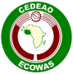

**ECOWAS COMMISSION COMMISSION DE LA CEDEAO**

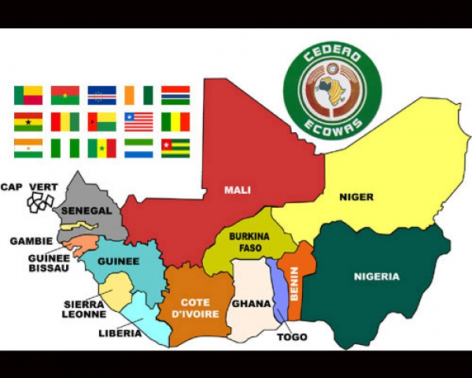 **ECOWAS RESEARCH AND INNOVATION SUPPORT PROGRAMME**

**(PROGRAMME PARI)**

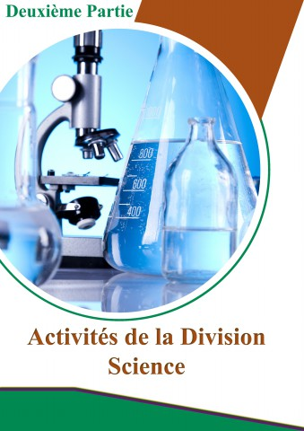

### **2020 CONDITIONS TO APPLY**

**OBJECTIVES**

**FINANCE RESEARCH PROJECTS BY CALL FOR APPEAL AND EQUIP THE LABORATORIES OF EXCELLENCE OF THE REGION**

1. **PRESENTATION**

The ECOWAS Research and Innovation Support Program (PARI) is a competitive program that aims to select the best projects submitted by researchers through calls for applications. It is included in the ECOWAS Science, Technology and Innovation Policy Action Plan (ECOPOST, Strategic Axis 2, Activities 2.1.4; Strategic Axis 3, Activities 3.2.1 to 3.2.3 and 3.1.13; Strategic Axis 7, Activities 7.1.2, 7.1.8; Strategic Axis 8, Activities 8.1.1, 8.1.2, 8.1.5) and is in close alignment with the Community Strategic Framework. (CSC) 2016-2020 of the ECOWAS, the African Union Strategy on Science, Technology and Innovation (STISA), the African Union Agenda 2063 and the Sustainable Development Goals (SDG-30). This program is implemented to respond to the many challenges of the research sector (obsolescence and degradation of equipment and infrastructure, low production of researchers, development of regional research programs, etc.).

1. **OBJECTIVES**

The PARI pursues the following specific objectives:

1. Financing research on a competitive basis of call for applications of research projects contributing to the fight against poverty and having an impact on the development of the region;
2. Promote the mobility of researchers through the development of regional projects;
3. Support research laboratories to strengthen their capacities (equipment and connectivity) and access to scientific information;
4. Build the capacity of young researchers to ensure the next generation of scientists of the research institutes within the region.
5. **RECIPIENTS**

The PARI shall award grants to two types of recipients[1]:

* ***Direct: Consortiums of researchers;***
* ***Indirect: Research organization or Laboratories.***

1. **ELIGIBILITY OF RESEARCH PROJECTS**
   1. **Terms of application**

The laboratories and research Institutions must fulfil the following conditions:

* Comply with the deadline for the submission of applications;
* Be located in one of ECOWAS member country;
* work in the field of Research in science, technology and Innovation;
* Apply in one of the fields identified by the call for applications;
* Propose an integrative and community research project within the ECOWAS directions;
* Fill out the Application form;
* Present a project of 10 pages maximum. The project must
* Have an impact on the development of the region;
* Contribute to the development of Science, Technology and Innovations through its results;
* Integrate young researchers (doctoral student, junior researchers) with the consideration of the gender issue;
* Contribute to the resolution of a sustainable solution;
* Contribute to the sustainable acquisition of equipment for research.

A letter of intent is required from each researcher who agrees to take part in the Consortium.

* 1. **Domain of research / Research Activities**

The PARI support projects for fundamental research, industrial research and experimental development projects. The PARI also provides support for technical feasibility studies preparatory to industrial research and experimental development. Each year, the IRAP subsidizes two (02) research projects in the chosen disciplines in the two (02) following fields:

1. ***Earth and Life Sciences: Earth Sciences*** *envelope all sciences relating to the Planet Earth covering (though not restricted to) the following disciplines:* ***geology, geophysics, geodesy, paleontology, etc****.* ***Life Sciences*** *involve all sciences on «organisms » such as plants, animals and human being. This may include* ***agro-technology, zootechnics, phytology, biotechnology, biology, science and environment, food science, medicine and tissue engineering****,* ***etc.***
2. ***Basic Science, Technology and Innovation****:* *Basic Science, Technology and Innovation includes any other sciences, technology and innovation apart from the sciences covered by Life and Earth Science. This may include* ***physics, chemistry, mathematics, engineering (mechanical, electrical, electronic and civil, etc), artificial intelligence, materials science, manufacturing and production technology, metallurgy, textile engineering, energy and innovation****, etc.* 
   1. **Integrative and community-based research project**

Under the PARI Program, research projects must be **integrative community-based**.

* Projects submitted by a ***Consortium of researchers***   
  are integrative when they are developed in partnership with **researchers from a third country speaking another official ECOWAS language (English, French, Portuguese) in order to promote regional integration**. The project promotes regional integration.
* Projects submitted by ***Consortiums of researchers*** are community-based within the meaning of ECOWAS when the Researchers participating in the Consortium necessarily come from the three (03) linguistic zones (Anglophone, Francophone and Lusophone) of ECOWAS.

1. **RESEARCH PROJECTS NOT ELIGIBLE**

**Project with a “Double funding”:** Only one grant may be awarded for any single project (in whole or in part) from PARI for one and the same beneficiary. Two projects shall be deemed similar when the projects (in whole or in part) present identical main objectives or have simply been adapted, **AND** comprise teams which are largely similar.

1. **EXPENDITURE NOT ELIGIBLE IN PROPOSALS**

Staff Expenses (salaries, bonuses and allowances), relevant social costs (including unemployment insurance contributions or allowances for loss of earnings at the end of the given contract) and tax on salaries, internship grants are not eligible under the PARI grant.

1. **PARI GRANT AMOUNT**
2. The PARI program allocates a grant each year. The amount of which is set from the budget of the Commission and in compliance with the provisions of the ECOWAS grant Code.
3. For the 2020 session, the PARI program allocates a grant in the amount of two hundred thousand dollars ($ 200,000) per research area;
4. For the 2020 session, the disciplines are: **Pharmacopoeia** (Life and Earth Sciences) and **CHEMISTRY** (Basic Sciences, Technology and Innovation).
5. **DISCIPLINES DOR THE SESSION 2020**

The PARI Program intends to focus on any current pandemics or epidemics that may occur in the region in the future. As such, research based on pharmacopoeia and innovations in services, processes, products and technologies should contribute to providing sustainable solutions to the populations of the region.

For the 2020 session, the disciplines are: **Pharmacopoeia** (Life and Earth Sciences) and **CHEMISTRY** (Basic Sciences, Technology and Innovation).

|  |  |  |
| --- | --- | --- |
| Award Domain of research: | ***Earth and Life Sciences*** | ***Basic Science, Technology and Innovation*** |
| Value | **200,000 US $** | **200,000 US $** |
| **Disciplines Session 2020** | **PHARMACOPOEIA** | **CHEMISTRY** |

1. **DURATION OF THE RESEARCH PROJECT**

The duration of the research proposal is three (3) years.

1. **INTERNATIONAL JURY (PROJECT SCIENTIFIC SELECTION COMMITTEE)**
2. The eligibility and evaluation of the projects is done by an international jury in accordance with the standards of competitive selection of projects, scientific excellence, quality of construction of the project and impact potential of the project described in a detailed proposal. The selection of laureates in the 2 fields will be based exclusively on the technical and scientific quality of the project in accordance with the PARI terms of reference.
3. The persons sitting on the Scientific Committee for the Selection of the projects (**Members of the International Jury**) are appointed *intuitu personæ* by the ECOWAS Commission on the basic of *scientific or technical expertise on the basis of reputation, independence, probity and overall and forward-looking vision recognised in their field of expertise or in a manner to ensure that decisions taken by the committee reflect a wide range of opinion*.
4. The final results will be communicated to all consortia that tendered in accordance with the provisions of the PARI Regulations and the ECOWAS Grant Code.
5. **CONDITIONS FOR THE IMPLEMENTATION OF RESEARCH PROJECTS**
   1. **Signature of a Grant Agreement**

* A Grant Agreement for the PARI Program is signed between the ECOWAS Commission and the winning Consortia of the PARI Program.
* The winning Consortia undertake to carry out the Research Project with the participation of all of its Partners designated under the specific conditions of the Convention as signed with ECOWAS under the direction of a Scientific Officer who is the coordinator of the Consortium.
* The Consortium Coordinator is the most senior scientist (***Minimum Level of Lecture***) with proven ten (10 years) experience in the conduct of research programs. He is the one who signs the convention with the ECOWAS Commission. He is required to inform all his partners of the existence of the Convention upon signature by the parties.
  1. **Consortium Agreements**

* A Consortium Agreement is signed by all Project Partners upon signature of the Convention with the ECOWAS Commission. This Agreement provides for the terms of cooperation and in particular the distribution of intellectual property rights between Partners.
* The development of a consortium agreement is not necessary if there is already an integrated mechanism which is the subject of a contract or a framework contract binding the Beneficiaries.
  1. **Condition for disbursement of the Grant**

The Condition for disbursement of the Grant will be applied in accordance with the provisions of the PARI Regulations and the ECOWAS Grant Code.

The disbursement rate of the grant to the Laureates is:

* 50% the first year.
* 50% the second year after audit of the first part of the disbursement

1. **SECRETARIAT OF THE PARI PROGRAM**

The PARI Program is managed by a Secretariat located within the ECOWAS Commission. It is this Secretariat which launches the PARI program each year and sets up the International Jury for deliberation.

1. **CEREMONY FOR GIVING GRANTS TO WINNING CONSORTIUMS**

The ECOWAS Commission awards the prizes to the Coordinators of the two (02) winning Consortia in their respective countries. The Award is presented by the Commissioner in charge of Education, Science and Culture of ECOWAS in the presence of the Minister in charge of Science and Technology. The prize consists of a symbolic check on which the amount of the Grant is mentioned and a plaque of recognition.

1. **ECOWAS MEMBERS STATES**

|  |  |  |  |  |
| --- | --- | --- | --- | --- |
| **ECOWAS MEMBER STATES** | Bénin  Burkina Faso  Cap Vert  Côte d’Ivoire | Gambia  Ghana  Guinea  Guinée Bissau | Liberia  Mali  Niger  Nigeria | Senegal  Sierra Leone  Togo |

1. **DEADLINE FOR THE SUBMISSION OF PROJECTS**

The projects must be submitted in sealed envelopes (**one signed original and 3 copies + electronic copy of the file in a USB key**) and clearly marked "**Selection of the best projects within the framework of the Research and Innovation Support Program** «**PARI PROGRAM**».The envelope SHALL also indicate the **bidder’s name** as well as **the chosen Discipline (Pharmacopoeia** OR **Chemistry).**

Expressions of interest SHALL be received at the address below no later than **Thursday, December 10, 2020 at 11:00 a.m. (GMT + 1) Nigeria time.**

**NB: projects must be submitted in the format of the PARI Session 2020 Application form.**

1. **ADDRESS**

The ECOWAS Tenders Reception Box remains located at **the Procurement Division, Directorate of General Administration, 1st floor of the ECOWAS Commission, located at 101 Yakubu Gowon Crescent, Asokoro District, P.M.B. 401 Abuja Nigeria.**

1. **MORE INFORMATION CONTACT**

Interested Consortia can obtain further information at the address indicated below, during working days and hours: Monday to Friday, 9 a.m. to 5 p.m. (GMT +1):

ECOWAS Commission, General Administration Directorate, Procurement Division, No. 101, Yakubu Gowon Crescent, Asokoro District, P. M. B. 401 Abuja, Nigeria; or by e-mail by writing to the following e-mail addresses: [procurement@ecowas.int](mailto:procurement@ecowas.int) , with a copy to [sbangoura@ecowas.int](mailto:sbangoura@ecowas.int) ; [ikkamara@ecowas.int](mailto:ikkamara@ecowas.int) and [rkouakou@ecowas.int](mailto:rkouakou@ecowas.int) ;

This call for expressions of interest can be viewed on the following website: <http://www.ecowas.int/doing-business-in-ecowas/ecowas-procurement/>

**Commissioner General Administration & Conference**

1. For the purposes of Community law, the recipient shall carry out an economic activity, that is, any activity which involves offering goods and/or services in a given market. Therefore, associations, learned societies can be recipients.