ANNEX II + III: TECHNICAL SPECIFICATIONS + TECHNICAL OFFER

Contract title: Supply and delivery of IT Hardware & Software to the ECOWAS Commission and the Member States for Small Arms and Light Weapons Database and Register p 1 /…
Publication reference: ECW/PSS – GRANT/RT/04/2020

Columns 1-2 should be completed by the contracting authority
Columns 3-4 should be completed by the tenderer
Column 5 is reserved for the evaluation committee
Annex III - the contractor's technical offer
The tenderers are requested to complete the template on the next pages:
- Column 2 is completed by the contracting authority shows the required specifications (not to be modified by the tenderer),
- Column 3 is to be filled in by the tenderer and must detail what is offered (for example the words ‘compliant’ or ‘yes’ are not sufficient)
- Column 4 allows the tenderer to make comments on its proposed supply and to make eventual references to the documentation
The eventual documentation supplied should clearly indicate (highlight, mark) the models offered and the options included, if any, so that the evaluators can see the exact configuration. Offers that do not permit to identify precisely the models and the specifications may be rejected by the evaluation committee.
The offer must be clear enough to allow the evaluators to make an easy comparison between the requested specifications and the offered specifications.

LOT 1 (SINGLE LOT): Supply and Delivery of IT Hardware & Software for Small Arms and Light Weapons Database and Register to ECOWAS Commission and Member States, to the following addresses:
Country | Physical Geographic Address
COTE D’IVOIRE | Commission Nationale pour les ALPC (COMNAT-ALPC), Abidjan
GHANA | National Commission on Small Arms and Light Weapons [NACSA] Accra
MALI | Secrétariat Permanent de la Lutte contre la Prolifération des Armes Légères et de Petit Calibre, Bamako.
BURKINA FASO | Secrétariat Permanent de la Commission Nationale de Lutte contre la Prolifération des Armes Légères Ouagadougou.
NIGER | Commission Nationale pour la Collecte et le Contrôle des Armes Illicites (CNCCAI) Présidence de la République du Niger, Niamey
BENIN | Commission Nationale de Lutte contre la Proliferation des Armes Legeres et de Petit Calibre, Cotonou.
CAPE VERDE | COMNAC, Direção Nacional da Policia Nacional, Praia,
THE GAMBIA | Ministry of Defence. Banjul
GUINEA | Commission Nationale de Lutte contre la Proliferation et la Circulation Illicite des Armes Legeres et de Petit Calibre, Conakry-
GUINEA BISSAU | Commission Nationale pour la Lutte contre la Proliferation des Armes Legeres et de Petit Calibre (CNLCPALPC), Bissau
LIBERIA | Liberia National Commission on Small Arms (LiNCSA), Monrovia
NIGERIA | Nigeria Presidential Committee on Small Arms and Light Weapons (PRESCOM), Abuja
SENEGAL | Secretariat Permanent de la Lutte contre la Proliferation des Armes Legeres et de Petit Calibre- Senegal (Comnat/ALPC), Dakar
SIERRA LEONE | Sierra Leone National Commission on Small Arms (SLeNCSA), Freetown
TOGO | Commission Nationale de Lutte contre la Prolifération, la circulation et le trafic illicites des Armes Légères et de petit calibre (CNLPAL), Lome
ECOWAS COMMISSION | 101, Yakubu Gowon Crescent, Asokoro, Abuja, Nigeria

1.  Item number | 2.  Specifications required | 3.  Specifications offered | 4.  Notes, remarks,  ref to documentation | 5.  Evaluation committee’s notes
1.  SERVER  Qty 02 delivered as follow:  - ECOWAS Commission | BLADE SERVER  Blade Enclosure x 1  Switching Engine Fabrics  - HP BL460c Gen 8 Blade Servers  - Two (2) intel ® Xeon ® E5-2600 family processors  - Processors: 2 x Intel Xeon E5-2643 2.00 GHz  - 16 cores  - Bus Speed 400MHz minimum  - 2 x Hot Plug SFF SAS 4.0TB Internal  - 256GB ECC DDRAM Memory, 1MB Cache 3  Upgrade of existing server by acquisition of a blade server that will plug into an existing enclosure.  Price to include installation, configuration and support for 3 years for servers (DC & DRC)
2. CENTRAL SERVER  Qty 02 delivered as follow:  - ECOWAS Commission | HPE 3PAR SAN STORAGE  Additional hard disk capacity to existing SAN storage  - 2 x 10TB  - NL Storage  - (including installation & support)  Upgrade of existing HP 3Par Storage  Price to include installation and configuration
3. DESKTOP SYSTEMS  Qty 40 delivered as follow:  - 02 Cote d’Ivoire  - 02 Cape Verde  - 02 Benin  - 02 Burkina Faso  - 02 The Gambia  - 03 Ghana  - 02 Guinea  - 02 Guinea Bissau  - 02 Liberia  - 02 Mali  - 02 Niger  - 05 Nigeria  - 03 Senegal  - 02 Sierra Leone  - 02 Togo  - 05 ECOWAS Commission | DESKTOP SYSTEMS  Intel Core i5 Processor 2.93Ghz  Bus Speed 1066 MHz  1TB Disk Drive SATA  16GB DDRAM Memory (minimum)  1MB Cache 2 (minimum)  1 GB Video Memory  Flash Disk, 8GB, USB  DVD/CD-RW IDE 52x  Int. Network Card 1000Mbps full-duplex  2nd wireless NIC & accessories  Keyboard (French and English), Wheel Mouse  20 ‘’ Flat Display  UPS 1500VA APC
4. PRINTER  Qty 02 delivered to ECOWAS Commission | LASERJET PRINTER (LAN PRINTER)  Desktop Colour Printer  LaserJet, 28 pages/min  Memory: 128MB (min)  A4/Legal paper capable  Jet Direct 10/100 Base-TX print server card  Wireless network  Network & USB interface  Supply with Cat-6 Patch Cord and USB Cable
5. PRINTER  Qty 02 delivered to ECOWAS Commission | DESKTOP B/W PRINTER  LaserJet, 40 pages/min  Memory: 128MB (min)  A4/Legal paper capable  Gigabit Ethernet & USB interface ports  Cable: Supply with USB Cable
6. NOTEBOOK SYSTEMS  Qty 20 delivered as follow:  01 Cote d’Ivoire  01 Cape Verde  01 Benin  01 Burkina Faso  01 The Gambia  01 Ghana  01 Guinea  01 Guinea Bissau  01 Liberia  01 Mali  01 Niger  01 Nigeria  01 Senegal  01 Sierra Leone  01 Togo  05 ECOWAS Commission | NOTEBOOK COMPUTER  Intel Core i5-2620M 1.60GHz Processor or higher  Bus Speed 1333MHz  1TB Disk Drive SATA  16GB DDR3 SDRAM Memory  6MB L2 Cache 2  1GB Video Memory  14” TFT Display  DVD-RW Dual Layer Drive  Int. Network Card 100Mbps full-duplex  Ethernet 802. 11b & Diversity Antennae  Carrying case  External mobile disk drive 2TB USB
7. SCANNERS  Qty 36 delivered as follow:  01 Cote d’Ivoire  01 Cape Verde  01 Benin  01 Burkina Faso  01 The Gambia  01 Ghana  01 Guinea  01 Guinea Bissau  01 Liberia  01 Mali  01 Niger  02 Nigeria  01 Senegal  01 Sierra Leone  01 Togo  05 ECOWAS Commission | SCANNERS  Type: Flatbed  Scan resolution: 2400 dpi  Automatic Document Feeder (50-Sheet)  ADF speed: Up to 8 ppm/ 4 ipm  2-Sided Multi-page Scan  Connectivity: USB 2.0  Paper Size: A4/Legal  Supply with USB Cable  Software Standard  Compatible O/S: Windows 7, 8 & 10
8. SECURITY APPLIANCE  Qty 02 delivered as follow:  - ECOWAS Commission | CISCO FIREWALL  Configuration of two (2) existing units Cisco Firewall 5545ASA
9. OPERATING SYSTEM  Qty 02 delivered as follow:  02 ECOWAS Commission | Bare Metal Operating System  - 2 x VMWare EXSi 6.5 with 3 yrs support  - 1 xVcenter server Enterprise Edition
10. APPLICATION ACCESS SECURITY SOFTWARE  Qty 70 delivered as follow:  05 Cote d’Ivoire  04 Cape Verde  03 Benin  04 Burkina Faso  04 The Gambia  05 Ghana  04 Guinea  04 Guinea Bissau  04 Liberia  04 Mali  04 Niger  07 Nigeria  05 Senegal  04 Sierra Leone  04 Togo  05 ECOWAS Commission | APPLICATION ACCESS SECURITY SOFTWARE  To Protect the following  - On-Premises Applications  - VPNs  - Web Applications  Protection Type  - Hardware Token  - Soft Token  Optional billing Model  - Perpetual pricing model
11. VPN CLIENT SOFTWAREMS  Qty 60 delivered as follow:  04 Cote d’Ivoire  03 Cape Verde  03 Benin  04 Burkina Faso  03 The Gambia  05 Ghana  03 Guinea  03 Guinea Bissau  03 Liberia  04 Mali  04 Niger  06 Nigeria  04 Senegal  03 Sierra Leone  03 Togo  05 ECOWAS Commission | CYBEROAM VPN CLIENT SOFTWARE  CybeRoam VPN Client Software
12. Smart Television  Qty 2 delivered to the ECOWAS Commission | New Sony KD-65XF8505 (65 inch) 4K Ultra HD Smart HDR Television – Black  - Bluetooth enabled  - Wi-Fi enabled  - Touch Screen  - Microsoft Office enabled
13. Projector  Qty 2 delivered to the ECOWAS Commission  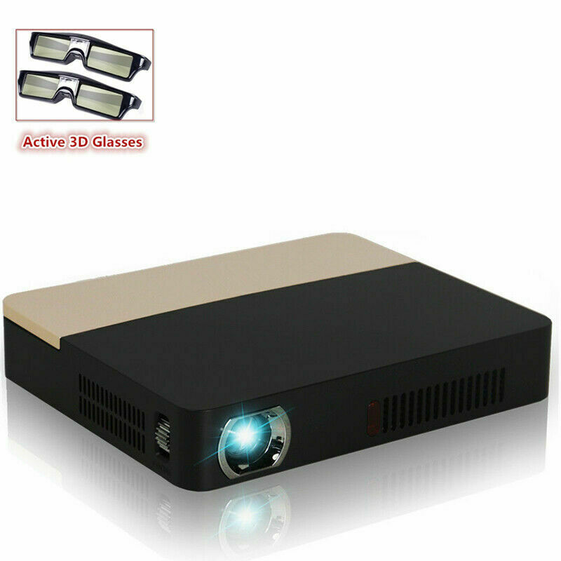  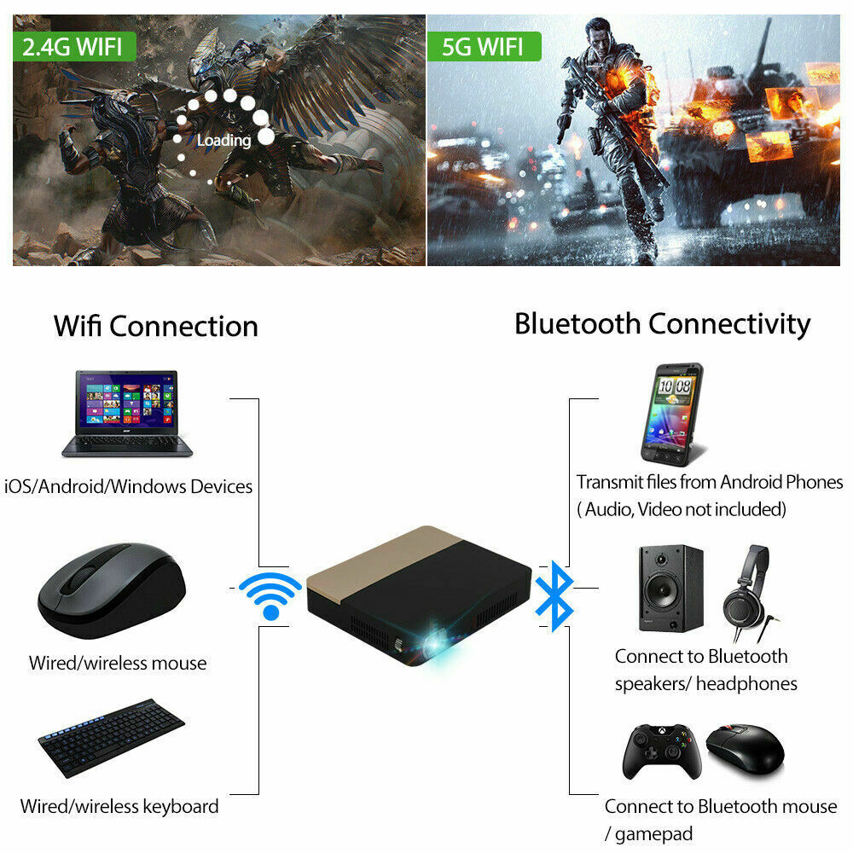  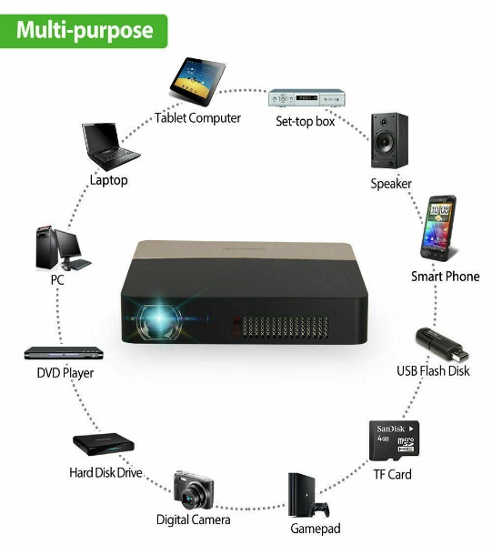 | True 8500 Lumens 4K HD 1080P DLP Projector 3D Wifi Home Theater Cinema RJ45 HDMI  - DLP  - Blue Tooth Enabled  - Support PPT, PDF etc  - Internet/Wi-Fi Enabled  - Multi-purpose  - USB Cable  - HDMI  - Speaker Connectivity  - Wired/Wireless Keyboard  - Wired/Wireless Mouse  - Projector Carrier Bag

