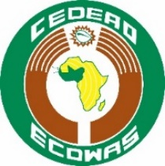 |  | 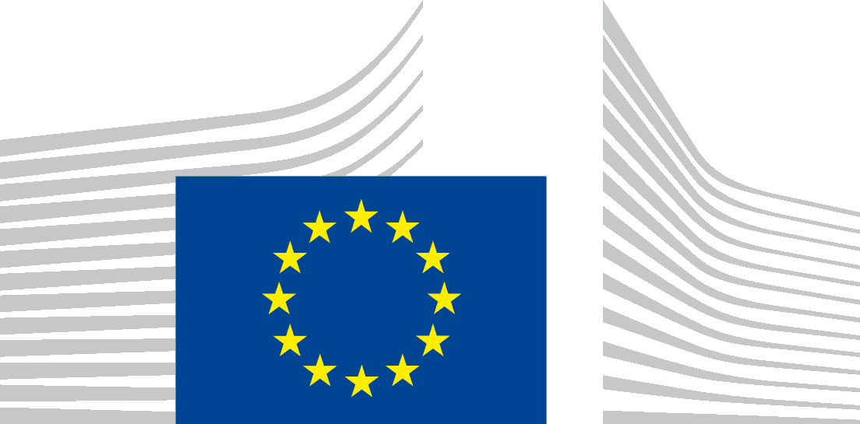
ECOWAS/CEDEAO |  | EUROPEAN DEVELOPMENT FUND
Contract Title: Supply, Installation, Testing and Commissioning of 2-Units of 35Kwp Grid Interactive Roof Top Solar PV plants
Publication Reference: EuropeAid/140-613/ID/SUP/ROC
The Economic Community of West African States (ECOWAS) intends to award a supply contract for the supply and installation of solar PV systems for powering selected offices and equipment at the Sèmè-Kraké Joint Border Post Facility. The project includes site preparation, assembling of PV modules, inverter, battery bank, distribution boards and cabling, communication interface, and any other equipment necessary for safe and efficient operation of the Solar Power Plant.
The work is to be implemented with financial assistance from the 10th EDF programme of the European Union.
The tender dossier is available from:

The Imprest Administrator
Transport Facilitation Project II
Department of Infrastructure
ECOWAS Commission Annex,
Room 104, Ground Floor,
ADAMAWA Plaza,
Plot 1099, First Avenue, Central Area,
Federal Capital Territory, ABUJA
Nigeria
Tfp2@ntu.eu
It will also be published on the website of DG International Cooperation and Development: https://webgate.ec.europa.eu/europeaid/online-services/index.cfm?do=publi.welcome and will also be published on the ECOWAS website.
The deadline for submission of tenders is Wednesday, 12th February, by 16:00 Local time. Possible additional information or clarifications/questions shall be published on the on the website of DG International Cooperation and Development: https://webgate.ec.europa.eu/europeaid/online-services/index.cfm?do=publi.welcome and ECOWAS website.

