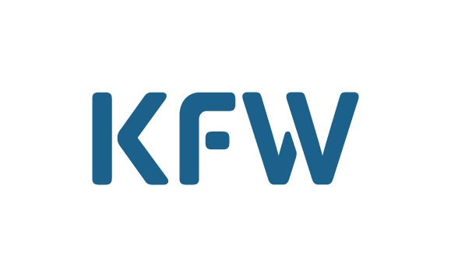
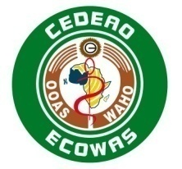
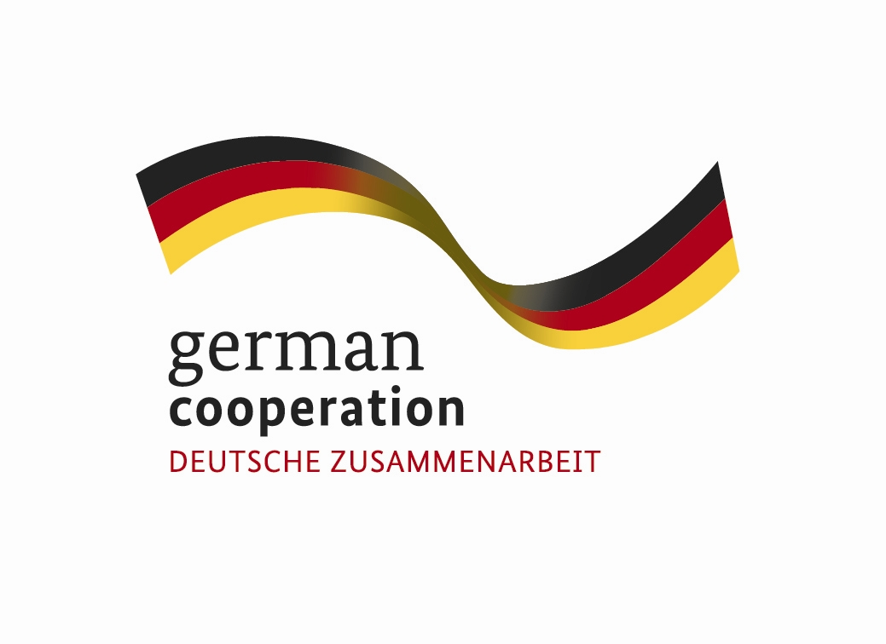

WEST AFRICAN HEALTH ORGANISATION (WAHO)
******
Regional “Reproductive Health and HIV Prevention Programme” in the Economic Community of West African States (ECOWAS)

******
CALL FOR EXPRESSION OF INTEREST
Reference N°FM/TEND/AMI/PROJETS KFW/2018/015/bk
FOR THE SELECTION OF CONSULTANCY FIRMS

EXTERNAL AUDIT OF THE Regional Reproductive Health and HIV Prevention Programme in the ECOWAS REGION

Funding: German Cooperation / KFW
The West African Health Organisation (WAHO) received a Grant from the German / KFW Cooperation to implement activities of the Regional "Reproductive Health and HIV Prevention” Programme in the Economic Community of West African States (ECOWAS) and intends to use part of the funding to make payments under the following contract: RECRUITMENT OF A CONSULTANCY FIRM TO CONDUCT AN EXTERNAL AUDIT OF THE FINANCIAL YEARS 2018-2021.

The Consultancy Firm shall conduct financial audits to assess the regularity of expenditures made by the Regional "Reproductive Health and HIV Prevention” Programme in the Economic Community of West African States (ECOWAS) and its implementing partners which are the Ministries of Health of the seven countries (Benin, Burkina Faso, Ghana, Guiné-Bissau, Mali, Niger and Sierra Leone) and some of the Associations working in the field of Reproductive Health for the financial years 2018-2021.

Specifically, auditing the Programme for financial 2018-2021 (01 April 2018 to 31 March 2021) will serve to provide a reasonable guarantee and a well buttressed opinion to KfW that the allocated resources are being managed in accordance with :
- The Programme Procedures Manual validated by the 2014 Annual Review;
- Internationally accepted financial regulations, rules, practices and procedures;
- Directives prescribed in the Programme’s foundation documents, including provisions pertaining to monitoring, evaluation and reporting;
- ECOWAS procedures and norms in the areas of accounting, financial management, award of contracts for the procurement of goods and equipment and finally of reporting (financial reports, progress reports, etc).

Duration of Mission

The estimated duration of the audit is 45 days. The audit report is expected to be available no later than 15 May of each year.

Mission Period
- April 2018-May 2019;
- April 2019-May 2020;
- April 2020-May 2021.

Consultant's Profile
WAHO now invites qualified Independent Audit and Chartered Accounting Firms which are regularly involved in account review activities and duly registered with Chartered Accountants Associations internationally recognized by IFAC or FIDEF Associations of Chartered Accountants and with proven experience in financial audit of development projects, to indicate their interest in providing the services.

The West African Health Organisation (WAHO) invites qualified consultancy firms (consultants) to express their interest in providing the aforementioned services. Interested consultants must demonstrate that they possess the required qualifications and relevant experience (documentation on the firm and its areas of competence, references on past execution of similar contracts) for the execution of the services. The cover and signature pages of the said contracts must be attached to the references. A summary description of the references must include the aim of the mission, the address of the client, the cost of the project, year of completion, and duration. These criteria will be duly considered when short-listing.

The Consultancy firm will be selected based on the Least Cost Selection (LCS) in accordance with the ECOWAS procurement code (effective from 1 January 2014).

Interested consultants may also obtain additional information on reference materials from the aforementioned address and during work hours from Monday to Friday 08h00 to 16h00.

The expression of interest with the reference "Recruitment of a firm to conduct an external audit of the Regional Reproductive Health and HIV Prevention in the Economic Community of West African States (ECOWAS) 2018-2021" for 2016 on the envelope may be received by the WAHO secretariat via post or email at the address below no later than 11.00 a.m (GMT) on 30 November 2018.

Address :
West African Health Organisation
01 BP 153 Bobo-Dioulasso 01
Avenue Ouezzin COULIBALY
Burkina Faso
Telephone: (226) 20 97 57 75/ 20 97 00 97
Fax: (226) 20 97 57 72
Email address: offres@wahooas.org

Prof. Stanley OKOLO
Director General

