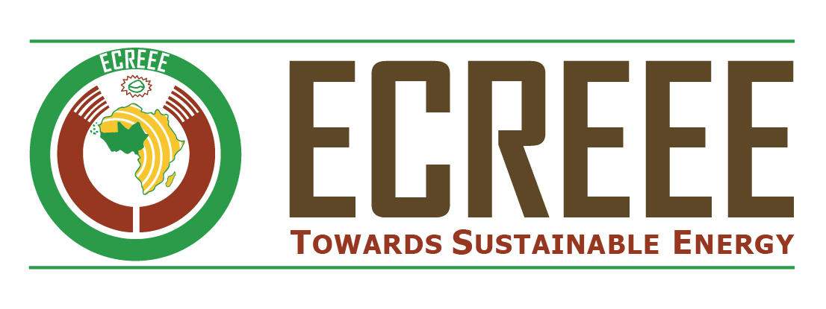

**REQUEST FOR EXPRESSIONS OF INTEREST**

**(CONSULTING SERVICES)**

ECOWAS – Cote d’Ivoire, Ghana, Nigeria and Senegal

**Feasibility Study on Business Opportunities for Women in a Changing Energy Value Chain in West Africa**

Sector: Energy

Grant Number: 5150155002452

Project ID Number: P-Z1-FZO-009

1. The ECOWAS Centre for Regional Renewable Energy and Energy Efficiency (ECREEE) has received a Grant of USD 1,000,000 from African Development Bank through the NEPAD –Infrastructure Project Preparation Facility Special Fund (NEPAD-IPPF Special Fund), and intends to apply part of the agreed amount for this grant to payments under the contract to finance the **‘Feasibility study on business opportunities for women in a changing energy value chain in West Africa’.**
2. The Project seeks to ensure that the region meets its goal of universal energy access for its over 300 million people, by developing a high quality, gender responsive, regional energy market development strategy that taps into the innate entrepreneurial capacity of ECOWAS women. Through development of bankable feasibility studies, the Project seeks to harness this capacity towards increasing the establishment of energy businesses and deployment of energy technologies to meet the energy needs of the region’s mostly unserved population.
3. The first part output of the Pre-feasibility Study which focused on four countriesNigeria, Ghana, Cote d’Ivoire and Senegal, as representatives of the ECOWAS region. This study identified four-country focused feasible business ideas (also referred to as ‘projects’), to be developed further into four bankable feasibility study templates (information memorandums), which will support the project promoters (i.e. the women entreprenuers) to raise funds. **The Pre-feasibility Study can be downloaded here:** <http://www.ecreee.org/procurement/feasibility-study-business-opportunities-women-changing-energy-value-chain-west-africa>
4. The four projects selected are viable products and services in the clean energy sector expected to enable West African women entrepreneurs:
5. streamline their current businesses with that product and/or service,
6. diversify into that product and/or service,
7. set-up a new entrepreneurial venture dealing with that product and/or service.
8. Presented below are the four projects to be evaluated and developed into a comprehensive feasibility study in line with this assignment:
9. Development of Liquefied Petroleum Gas (LPG) Distribution business in Nigeria with possibilities to replicate the same model in Cote d’Ivoire, Ghana, and Senegal
10. Development of Solar based electricity generation systems and solar lighting products distribution business in Ghana with possibilities to replicate in Nigeria, Cote d’Ivoire, and Senegal
11. Development of Clean Energy Powered Mini and Micro Grid electricity generation and distribution business in Senegal with provision for development in Nigeria, Cote d’Ivoire, and Ghana
12. Identification and development of Smart Applications for Energy Consumers in Cote d’Ivoire with possibilities to replicate in Senegal, Nigeria, and Ghana.
13. The Feasibility Study will be completed over a period of eight (8) months. And the overall duration of the assignment is ten (10) months from signing of the contract to implementation of the Investment Forum slated for May 2019. The team should be fluent in English and French. The Working Language for this assignment is English.
14. ECREEE invites consulting firms (specialized in undertaking technical and legal feasibility studies and developing information memorandums for presentation to debt and equity investors) to submit their candidacy for the services described above. Interested consultants must provide information indicating that they are qualified to perform the services (brochures, description of similar assignments, experience in similar conditions, availability of appropriate skills among staff, etc.). Consultants may constitute joint-ventures to enhance their chances of qualification.
15. Eligibility criteria, establishment of the shortlist and the selection procedure shall be in accordance with the African Development Bank’s “Rules and Procedures for the Use of Consultants” (May 2008 edition – revised in July 2012), available on the Bank’s website: http://www.afdb.org. Each consortium shall submit one Expression of Interest. Firms shall not form part of more than one consortium.
16. Interested consultants can obtain further information through the contact details provided below during office hours (9.00 AM – 5.00 PM Cape Verde time). Queries may be submitted up to 1 week before EOI submittal.
17. Expressions of interest must be in English and delivered in written form; one signed original, two copies, plus one softcopy (on CD-ROM or memory stick) in person, or by registered mail to the addresses below by 8th June 2018 at 10.00 AM Cape Verde time. Submissions should be made using the specified template **available at:** <http://www.ecreee.org/procurement/feasibility-study-business-opportunities-women-changing-energy-value-chain-west-africa>

For sealed envelopes or emails the following subject should be quoted: “**Feasibility Study on Business Opportunities for Women in a Changing Energy Value Chain in West Africa /Expression of Interest**.”

**For more information, delivery in person or by registered mail, contact the following:**

Ms MADUEKWE Monica

Project Manager

E-mail: mmaduekwe@ecreee.org

*With copy to*

Mr. BANGOURA Seydou Kassory

Principal Procurement Officer ECOWAS Commission

E-mail: sbangoura@ecowas.int

Mr. OLIVEIRA Alcides

Admin HR Officer ECREEE

E mail: [adeoliveira@ecreee.org](mailto:adeoliveira@ecreee.org)

ECOWAS Centre for Renewable Energy and Energy Efficiency,

Achada Santo Antonio,

Electra Building, 2nd floor,

C.P. 288, Praia, Cape Verde

**Mahama Kappiah**

**The Executive Director**

**ECOWAS Centre for Renewable Energy and Energy Efficiency (ECREEE)**