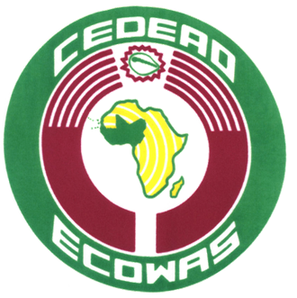
COMMUNIQUE DE PRESSE
PRESS RELEASE

N°xxx/2015 Abuja, 22nd November 2015

ECOWAS DEPLOYS A 133-MEMBER MISSION TO OBSERVE THE BURKINA FASO PRESIDENTIAL ELECTION ON 29 NOVEMBER 2015
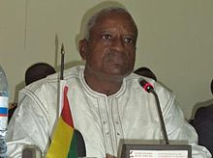
The Head of the ECOWAS Electoral Observer Mission, Manuel Serifo Nhamadjo

The former president of the transition in Guinea-Bissau, Manuel Serifo Nhamadjo, will lead the Economic Community of West African States’ (ECOWAS) short-term electoral observation mission on the Burkinabe presidential election scheduled for Sunday, 29 November 2015.
The ECOWAS mission, due to be deployed pursuant to ECOWAS Supplementary Protocol on Democracy and Good Governance, will mainly aim at ensuring the proper conduct of the electoral process to ensure free, transparent and credible elections.
The mission will comprise 133 observers, including 13 long-term and 120 short-term observers. The short-term observers will come from all ECOWAS Member States, excluding Burkina Faso, the Community Court of Justice, the ECOWAS Council of the Wise and the ECOWAS Parliament. The short-term mission team will also include representatives of national electoral commissions in the region as well as experts trained at the Kofi Annan International Peacekeeping Training Centre in Accra, Ghana.
On the other hand, the 13 long-term observer team will include experts in security matters, gender issues, electoral operations, constitutional law and communication.
The short and long-term mission teams will be supported in the field by the ECOWAS Commission’s technical support team composed of the ECOWAS Commissioner for Political Affairs, Peace and Security and the Director of Political Affairs, Mrs Salamatu Hussaini Suleiman and Dr Remi Ajibewa respectively. The head of the ECOWAS Electoral Assistance Directorate, Mr Francis Oké, and several other ECOWAS staff will also join the team.
The observers will be deployed throughout the country to observe and monitor all operations before, during and after the elections and present a report on the electoral process. The observation will particularly involve regularity, transparency, fairness and proper conduct of presidential elections.
After the elections, the ECOWAS election observation mission will give its opinion and, when the need arises, make recommendations to the various stakeholders in the electoral process, following the opening remarks of the head of the mission, Manuel Serifo Nhamadjo, at a press conference scheduled for 30 November 2015 in Ouagadougou.
Fourteen (14) candidates are running for the elections previously postponed in the wake of the failed coup of 17 September 2015. They include Ram Ouédraogo, Ablassé Ouédraogo, Zéphirin Diabré, Victorien Tougouma and Tahirou Barry. Roch Marc Christian Kaboré, Jean-Baptiste Natama, Saran Séré Sérémé, Françoise Toé as well as Bénéwendé Sankara are also running for the elections. Issaka Zampaligré, Adama Kanazoé, Boukaré Ouédraogo and Salvador Yaméogo are also hoping to run for the Burkina Faso presidential elections.
ECOWAS appeals to all candidates, political party leaders and their militants and supporters to ensure that the elections are held in an atmosphere of peace and tranquility and a spirit of national cohesion.

