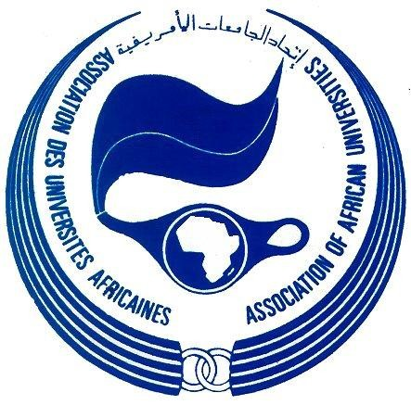
ECOWAS-AAU Staff Exchange Programme
Promoting Academic Mobility in the ECOWAS Region

Introduction
The AAU is pleased to announce the 2015 maiden edition of the Economic Community of West African States (ECOWAS), Staff Exchange Programme under the ECOWAS Academic Mobility Scheme. The Exchange Programme aims at facilitating academic mobility and encouraging networking among ECOWAS member institutions, as well as contributing to improvements in the quality of training and research in West African higher education institutions.

Under the Staff Exchange Programme, academic staff from universities in West Africa, or West African academics in the Diaspora, are sponsored to undertake visits to universities in West Africa to offer services such as teaching, graduate theses supervision, serving as external examiners or engaging in joint research.

Advantages
Staff Exchange missions allow academic staff to get acquainted with different work environments, mentor young scholars or researchers and meet their colleagues involved in the same research areas and in the long term help build cooperation between sending and hosting institutions.

The Duration of Visit
Duration: Minimum of 4 weeks (one month) and maximum of 3 months
The visit to the host institution under the ECOWAS Staff Exchange Programme involves participation of the Staff Exchange Fellow in teaching, supervision and related assignments.
.
Disciplines

For the lectureship assignments, Exchange Fellows are expected from all disciplines linked to the following fields of strategic importance to the West African region such as:
- Science, Technology, Engineering and Mathematics (STEM);
- Earth and Life Sciences including Environment and Climate Change;
- Health (Medical, Veterinary and Health Sciences);
- Agriculture;
- History of Africa; and
6. Information Communication Technology.

Please note that applications are accepted all year round.
Women are especially encouraged to participate in the Programme. Heads of various units of ECOWAS member institutions are therefore requested to give priority attention to the selection of women for the Staff Exchange Programme.

ECOWAS Financial Support
The ECOWAS will support up to 13 staff exchange missions including the academics from the Diaspora of the ECOWAS Community’s descent during the year 2015.
Financial support for exchange fellows includes the following:
- US$1,500 to cover economy class air ticket or the equivalent; and
- US$5,000 honorarium for the mission.

West African academics from the Diaspora who will spend part (2-3 weeks) of their sabbatical leave in an ECOWAS member institution for purposes of teaching and graduate supervision will receive a maximum of US$5,000.

Home/Host Institution Obligations
The home institution of the visiting professor/lecturer shall maintain the payment of his/her salary and benefits for the duration of his/her absence from the institution for the purpose of the exchange mission.

The requesting institution shall cater for the local expenses of the visiting professor/lecturer including lodging, board, local transportation, and medical care during his/her stay at the institution.

Who Can Apply?
University professors/lecturers from ECOWAS member institutions are invited to apply for the ECOWAS Staff Exchange Pogramme by providing evidence of request for his/her services from the Head of Department/Dean/Director/Provost of the institution where the services are needed.
The applying professor/lecturer is expected to complete the attached Application Form.

Submission of Application
Prospective Exchange Fellows from an ECOWAS member institution should submit the following documents to AAU:
  - An official letter requesting the services of the professor/lecturer from the Head of Department/Dean/Director/Provost of the ECOWAS host institution.
  - A duly completed application form.
  - Most recent Curriculum vitae.
  - Evidence of release from the university of the professor/lecturer

Application documents should be sent electronically to:
Secretary General
Association of African Universities (AAU)
Accra, Ghana
Email: secgen@aau.org

